

|  |
| --- |
| Министерство образования Республики Беларусь  Учреждение образования  Международный государственный экологический  университет имени А.Д.Сахарова |

Кафедра иностранных языков

**УЧЕБНО-МЕТОДИЧЕСКИЕ РЕКОМЕНДАЦИИ**

**ПО РАБОТЕ С НАУЧНОЙ СТАТЬЕЙ**

**ДЛЯ СТУДЕНТОВ 4-5 КУРСОВ ФАКУЛЬТЕТА ЗАОЧНОГО**

**ОБУЧЕНИЯ СПЕЦИАЛЬНОСТИ «МЕДИЦИНСКАЯ ЭКОЛОГИЯ»**

Минск 2014

Авторы- составители:

старший преподаватель кафедры иностранных языков

МГЭУ им. А.Д. Сахарова *Грицай Н.А*.

старший преподаватель кафедры иностранных языков

МГЭУ им. А.Д. Сахарова *Никитина Л.Н.*

Рецензенты:

к. фил.н., доцент, зав. кафедрой современных языков

ГУО КИИ МЧС РБ *Ковалева Т.Г.,*

к. пед.н., доцент, зав. кафедрой иностранных языков

МГЭУ им. А.Д. Сахарова *Малашенко Е.А.*

Учебно-методические рекомендации по английскому языку предназначено для студентов 5 курса факультета заочного обучения. В рекомендациях предлагаются аутентичные научные статьи и задания к ним для формирования навыков и умений работы с научной статьей

Учебно-методические рекомендации адресованы студентам заочной формы обучения в неязыковом вузе и рассчитаны на тех, кто овладел базовым лексико-грамматическим материалом, имеет определённый словарный запас и знаком с основными грамматическими понятиями. Данные рекомендации направлены на формирование иноязычной компетенции будущего специалиста, позволяющей использовать английский язык как средство обучения на языке специальности.

Учебно-методические рекомендации могут быть использованы как материал на практических занятиях, так и для самостоятельной работы студентов.

Целью данных рекомендаций является научить студентов поэтапной работе с научной статьёй, составлению глоссария и анализу любой статьи по специальности.

Рекомендации состоят из двух частей, каждая представлена аутентичным текстом (научная статья) медико-биологического профиля, а также рядом послетекстовых заданий с целью развития и совершенствования умений устной монологической речи с использованием коммуникативных фраз и необходимых для изучения лексических единиц.

Данные рекомендации так же позволят студентам обогатить свой словарный запас по выбранной специальности.

**PART 1**

**1. Pre-Reading**

*Skim the article and say what the subject of the article is and try to understand the general idea of it.*

*Digestive Diseases and Sciences, Vol. 40, No, 7 (July 1995), pty . 1420-1422*

Dermatoglyphic Patterns in Children with Chronic Constipation

ROBERT A. DRONGOWSKI, MS and ARNOLD G. CORAN, MD

Dermatoglyphic patterns, an analysis of the fine ridge configurations on the digits of the palms and soles, theoretically could be used in the diagnostic evaluation of certain medical disorders, since formation of these patterns is under genetic influence (1, 2). Since Galton (3) first systematically studied fingerprints and identified the fundamental formations (arches, loops and whorls), it has been established that certain dermatoglyphic patterns are associated with a number of congenital anomalies (4-9).

A recent report has documented that a specific fingerprint pattern (arches) is seen in association with constipation and abdominal pain. These authors claimed that the fingerprint pattern was useful in distinguishing between functional constipation and constipation secondary to various organic disorders (10). Since we treat a large number of children with constipation (11), we decided to analyze the dermatoglyphic patterns in these patients in an attempt to confirm or refute the above reported association (arches).

**MATERIALS AND METHODS**

The palmar dermatoglyphic patterns of 161 children with a primary diagnosis of either inguinal hernia (N = 84, controls) or constipation (functional, N = 39; organic, N = 38), seen in the pediatric surgery clinic, were examined. Each digit print was recorded as either an arch, whorl, or ulnar or radial loop (12). Each patient’s fingers were examined with a handheld magnifying glass and permanent records were obtained by using either a standard photocopying machine or the 3M Identifier System (St. Paul, Minnesota), an inkless fingerprint system.

Following each patient’s clinic visit, his/her hospital record was reviewed for the following information: previous medical history, sex, and age. Patients were divided into the following groups: functional constipation (N = 39), organic constipation (N = 38), [secondary to Hirschprung’s Disease (N = 17), im­perforate anus (N = 15) and other intestinal malfor­mations (N = 6)] and inguinal hernia (N = 84). Constipation was defined as a bowel frequency of less than once every two days with associated fecal incon­tinence for a period of no less than three months. All patients with constipation were referred to the pedi­atric surgical service following failed treatment by their referring physicians. Patients with inguinal her­nia had a negative history of constipation determined by hospital record review.

Children were further subdivided into arch posi­tive, ie, those having at least one arch identified on any digit of either hand, and arch negative, ie, those having any combination of loops and/or whorls on all 10 digits.

Informed consent was obtained from the parents in accordance with the standards established by the Hu­man Use Committee prior to data collection.

Statistical analysis was performed on the Michigan Interactive Data Analysis System (MIDAS), using analysis of variance and chi-square contingency table analysis with P < 0.05 considered significant.

RESULTS

There was no statistically significant correlation between arch positivity and functional constipation, organic constipation, and inguinal hernia (P = 0.9211) (Table 1).

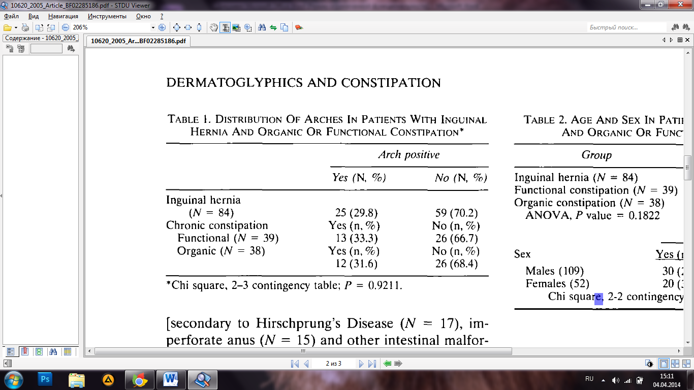

There were no significant differences in mean age between the three study groups (P = 0.1822). Addi­tionally, no significant correlation between arch pos­itivity and sex was evident (P = 0.1607) (Table 2).

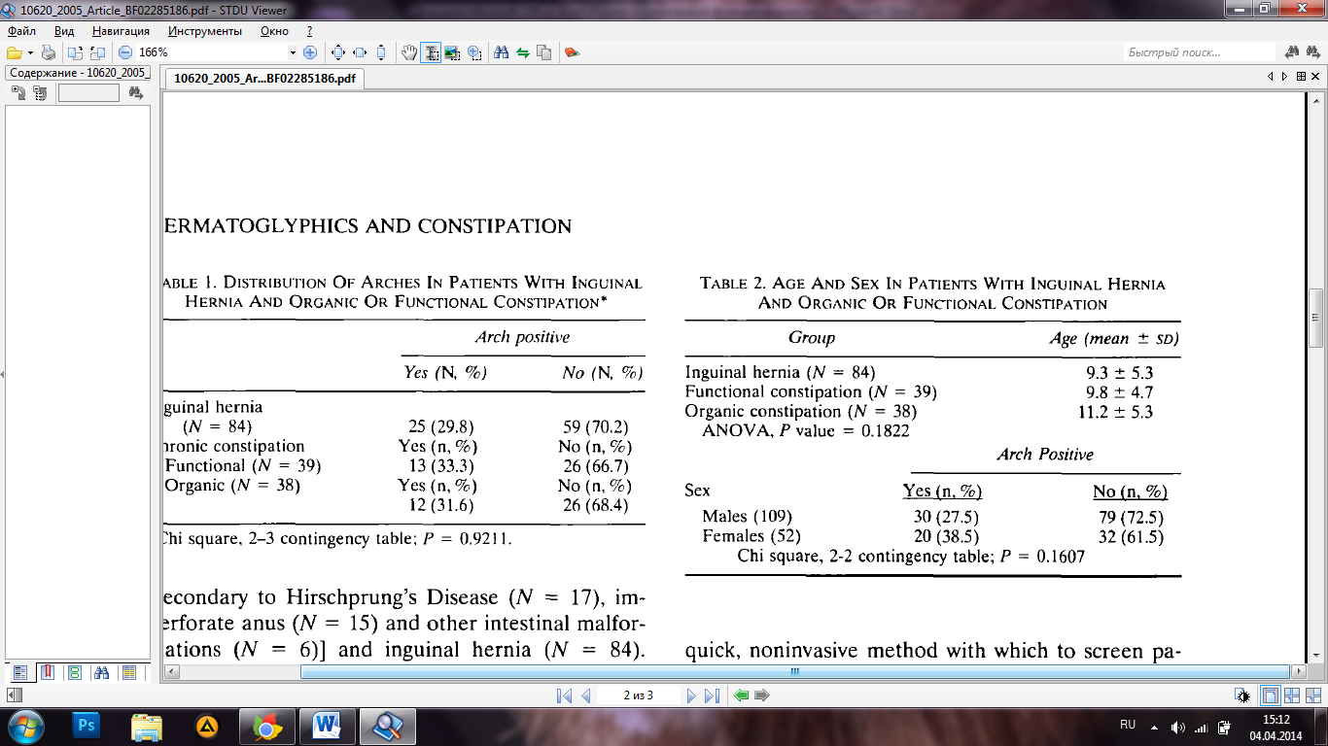

**DISCUSSION**

Numerous studies have attempted to correlate dermatoglyphic patterns with various medical conditions, both congenital (1, 4-6) and acquired (7, 13, 14) in origin. The rationale behind such inquiry is obvious: a quick, noninvasive method with which to screen pa­tients suspected of having some predisposition to a variety of diseases. However, in spite of the fact that several papers have been published demonstrating a correlation between dermatoglyphic patterns and specific medical conditions, including sexual dimor­phism (15, 16), the practical application of dermatoglyphics to medical diagnosis has not occurred. This is probably due, in large part, to skepticism by the medical community, a lack of well-controlled confir­matory studies, and the fact that several investigators defined a large number of medical conditions that could be categorized by dermatoglyphic patterns, thus ensuring nonspecificity. Follow-up studies to confirm the association of dermatoglyphic patterns with such disorders as duodenal ulcer (7), rubella (8), fetal wastage (17), pseudohypoparathyroidism (4), and congenital heart disease (9) have been rare. However, a study of dermatoglyphics and leukemia (18) failed to confirm the association of leukemia with a variety of unusual dermatoglyphic patterns reported by pre­vious investigators (19, 20).

Since our general pediatric surgery practice in­volves the care of a large number of children with chronic constipation (12), the study correlating der­matoglyphic patterns with early-onset constipation and abdominal pain aroused our interest (10). How­ever, in our study, no statistical correlation between arches and functional or organic constipation could be shown.

Correlations with sexual dimorphism (15, 16) have been previously reported; however, our study did not show any significant sex differences in the fingerprint analysis.

In conclusion, this study has demonstrated that no significant correlation exists between dermatoglyphic patterns and constipation, both functional and or­ganic. Therefore, the presence of arches on any digit of either hand cannot be used as a screening device for organically caused constipation.

REFERENCES

1. Alter M: Dermatoglyphic analysis as a diagnostic tool. Medi­cine 46:35-56, 1966
2. Cummins H, Midlo C: Fingerprints, Palms and Soles. New York, Doyer, 1961
3. Galton F: Fingerprints. London, Macmillan, 1892
4. Forbes AP: Fingerprints and palm prints (dermatoglyphics) and palmar-flexion creases in gonadal dysgenesis, pseudohypo­parathyroidism and Klinefelter’s syndrome. N Engl J Med 270:1268-1277, 1964
5. Preuss M, Fraser FC: Dermatoglyphics and syndromes. Am J Dis Child 124:933-943, 1972
6. Crawfurd M: Dermatoglyphics in partial C trisomies. Lancet 1:1195-1196, 1968
7. Habibullah CM, Mujahid M, Shivaprakash M, Iqbal MA, Ishaq M: Fingertip and palmar patterns in duodenal ulcer. Hum Hered 32:432-434, 1982
8. Swartz MH, Herman MV, Teichholz LE: Dermatoglyphic pat­terns in patients with mitral valve prolapse: A clue to patho­genesis. Am J Cardiol 38:588-593, 1976
9. Sanchez Cascos A: Finger-print patterns in congenital heart disease. Br Heart J 26:524-527, 1964
10. Gottlieb SH, Schustcr MM: Dermatoglyphic (fingerprint) evi­dence for a congenital syndrome of early onset constipation and abdominal pain. Gastroenterology 91:428-432, 1986
11. Katz C, Drongowski RA, Coran AG: Long-term management of chronic constipation in children. J Pediatr Surg 22:976-978, 1987
12. Hall JG, Froster-Iskenius UG, Allanson JE: Dermatoglyphics and trichoglyphics. In Handbook of Normal Physical Measure­ments. Oxford, Oxford University Press, 1989
13. Miller JR, Giroux J: Dermatoglyphics in pediatric practice. J Pediatr 69:302-312, 1966
14. Achs R, Harper RG, Siegel M: Unusual dermatoglyphic find­ings associated with Rubella embryopathy. N Engl J Med 274:148-150. 1966
15. Balgir RS: Dermatoglyphic studies in affective disorders: An appraisal. Biol Psychiatry 17:69-82, 1982
16. Penrose LS: Memorandum on dermatoglyphic nomenclature. Birth Defects 4:1-13, 1968
17. Rose LI, Gabbe SG, Teichholz LE, Villee DB, Williams GH: Dermatoglyphics associated with fetal wastage. N Engl J Med 287:451-452. 1972
18. Berka L, McClure PD, Sonley MJ, Thompson MW: Dermato­glyphics in childhood leukemia. Can Med Assoc J 105:476 — 482. 1971
19. Verbov JL: Dermatoglyphics in leukaemia. J Med Genet 7:125-131, 1970
20. Rosner F: Dermatoglyphics in leukaemia. Lancet 2:882-883, 1970
21. **Prepare control reading and translation of the extracts in bold.**
22. *The following coordinators and conjunction words can help you in better understanding of the extracts.*
23. *Find in the article sentences with the coordinators and conjunction words from 2.1 (5-10 sentences) and translate them into Russian.*

|  |  |  |  |
| --- | --- | --- | --- |
| after  although  and  as  asfar as  as if  as long as  as soon as  as through  as well as  because  before  both…and  but  either... or  for  hence  how  however  if  in case  in order (that)  neither... nor  nevertheless  nor  not only..., butalso  now (that)  on condition (that) | после того как  смthough  и; а; но  как; в то время как  поскольку; насколько  как будто  (до тех пор) пока, если только  как только  см. asif  так же как(и)  так как  прежде чем  как…,так и  но; а; однако; тем не менее  или…, или…  так как  следовательно  как  однако  если; если бы; ли  если  для того чтобы  ни... ни...  тем не менее  и... не  не только..., но и...  теперь когда  при условии если | once  or  (or) else  otherwise  provided (that)  providing (that)  since  so  so as  so long as  so that  still  supposing  that  that is why  therefore  though  thus  till  unless  until  what  when  where  whereas  whether  which  while  who  whose  why  yet | раз уж  или; иначе  в противном случае  в противном случае  при условии если  при условии если  с тех пор как; так как  так что; итак  чтобы; для того чтобы  см. as long as  так что  тем не менее  если; предположим (что)что; который  вот почему  поэтому  хотя; несмотря на  таким образом  до тех пор пока  если только... не...  до тех пор пока... не...  что; какой  когда  где  тогда как  ли  который  в то время как  кто; который  чей; которого  почему  тем не менее |

1. **Make the summary of the article.** 
   1. *Start with the structure of the article*

The article is called ……………….. .

It is published in (the name of the journal or any other scientific source of information) on (the date: day\month\year).

The article is written by (name of the author(s))

The research is done by the group of scientists\biologists from (name(s) of the laboratory\university\research center(s)….)

The article has 3/4/5 parts.

There are 3\4\5\ tables, charts, figures, pictures.

*b. Summarize each part of the article.*

**Read and learn the phrases you can use for article analysis.**

1. The subject matter of ***Introduction*** relates to (includes,  
   is devoted to).... -
2. The subject matter of ***Materials and Methods*** falls into two parts.
3. ***Results*** (the author in *Results*) discusses (deals with, is con­cerned with, covers, considers, gives considera­tion to, describes, gives an accurate description of, outlines, emphasizes, places emphasis-on) the problem of...
4. ***Discussion*** provides the reader with some data on... (some material on..., some information on..., an intro­duction to..., . a discussion of..., a treatment of..., a study of..., a summary of..., some details on....

**4. Say what your opinion on the information from this article is.  
Use the following phrases.**

1. A careful account is given of A
2. Detailed description is given of A
3. Thorough description is given of
4. Much attention is given to
5. Little attention is given to
6. Of particular (special, great, little)' interest is the me­thod of...
7. Of particular interest is the theory (discussion, treatment) of...
8. Of great (little) importance is the method of...
9. It is notable (noteworthy, praiseworthy, fortunate,, un­fortunate, a mistake, a slight disappointment) to the author's credit that...
10. The author has succeeded in showing (providing, pre­senting) the results of
11. The author failed to show (to exhibit, to provide, to present, to give an account of, to direct our attention to)...
12. **Find any article on the topic of your course paper or diploma work, choose any extract of 1600 typographical units, prepare control reading and translate it in written form.**
13. **Make a summary of the chosen article.**

**PART 2**

**Skim the article and say what the subject of the article is and try to understand the general idea of it.**

**The method of Allium anaphase-telophase chromosome aberration assay**

|  |  |
| --- | --- |
| Jette Rank  *Department of Environment,*  *Technology and Social Studies,*  *Roskilde University, P.O. Box 260,*  *DK-4000 Roskilde, Denmark.*  Phone: (+45) 4674 2071.  E-mail: jr@ruc.dk | Emissions of genotoxic chemicals from anthropogenic activities into envi­ronmental compartments require genotoxicity assays for the assessment of the potential impact of these sources on the ecosystems. The *Allium* anapha­se-telophase chromosome aberration assay has been developed as a method for rapid screening of chemicals and environmental samples. For determi­nation of sample concentrations prior to genotoxicity testing, a 96-h root growth inhibition test is carried out. In the chromosome aberration assay, root tip cells are investigated after a 48-h exposure. Bridges and fragments are scored as indicators of clastogenicity, and laggards or vagrant chromo­somes are considered indicators of spindle poisoning. The assay is simple and reliable and can be used for genotoxicity studies of wastewater, river water, contaminated soils and other complex mixtures.  Key words: *Allium сера,* genotoxicity, chromosome aberration, anaphase-telophase, complex mixture |

**INTRODUCTION**

Genotoxic chemicals used for many purposes in ma­nufacturing processes can be found in environmen­tal compartments such as air, water, soil and sediments. The chemicals can enter the environment from discharged wastewater, air emissions, during consumption of the products and from domestic and industrial waste sites.

For evaluation of environmental samples, many genotoxicity assays are used; among these, the Salmonella mutagenicity assay is the most commonly applied test system for complex mixtures (Claxton et al., 1998). However, many plant assays have also appeared to be useful and are in some ways superior compared to the Salmonella test. Plants are often more sensitive to heavy metals (Fiskesjo, 1988) than the Salmonella strains; moreover, it is possible to expose plants directly to complex mixtures or environmental samples either in the laboratory (Fis- kesjo, 1985) or in situ (Grant et al., 1992). The present paper describes the technical procedure of the Allium chromosome aberration assay, which was developed into a cheap and rapid screening test. The assay is a modification of the Allium test de­scribed earlier by Fiskesjo (1985). The test system was simplified so that only certain aberrations in the anaphase and telophase are scored.

**OUTLINE OF THE TEST SYSTEM**

The most important advantage of the Allium test is that it is a “low budget” method, which besides being fast and easy to handle also gives reliable results. The duration of the genotoxicity test is three to four weeks, including initial toxicity testing, scoring of aberrations, and statistics. It can be described briefly as follows:

*Week 1*: A 96-h root growth inhibition test is carried out in order to determine the toxicity level of the test chemical or environmental sample, and EC50 is determined by the dose-response relations­hip by interpolation.

*Week 2*: The 48-h genotoxicity test is carried out with 3-4 concentrations below the EC50, and the root tip cells are prepared for microscopic analysis.

*Week 3*: Chromosome aberrations are scored in anaphase and telophase cells.

*Week 4:* Calculations, statistics and reporting.

**MATERIALS AND CHEMICALS**

*The test organism*

The common onion, Allium cepa (Stuttgarter Rie- sen) is used. In Denmark, onions can be obtained from Dahnfeldt, Odense. The onions are sown in spring and harvested in late summer. The bulbs should be 15-22 mm in size and weigh 2-4 g. How­ever, onions of other sizes and sorts can be used. If kept dry at 10-15 °C, the onions can be used within a year after harvest. The onions need to rest for about two to three months before they are able to grow roots fast enough for the assay. The yellow shallows and the dry bottom plate inside the root primordia are carefully removed prior to the test.

*Glassware*

Figure 1 shows some special equipment used for the Allium test. The glass tubes (Wallin-glass) are bottomless, and a 70-mm ruler is mounted on the side of the glass and then used to measure the length of the root bundle. The beakers are made of polycarbonate and are disposable. This equipment is produced at our own laboratory, but the assay can also be carried out using normal test tubes in a rack and an ordinary ruler for the measurement of the root length. However, the advantage of this special equipment compared to the test tubes is that it is easier to change the test solutions in the bea­ker. A hole in the cover makes it also possible to aerate the solution in the beaker, which is more complicated if six test tubes are used. One disad­vantage of using one beaker instead of six test tu­bes is that the volume of test solution is about twice as large as for test tubes.

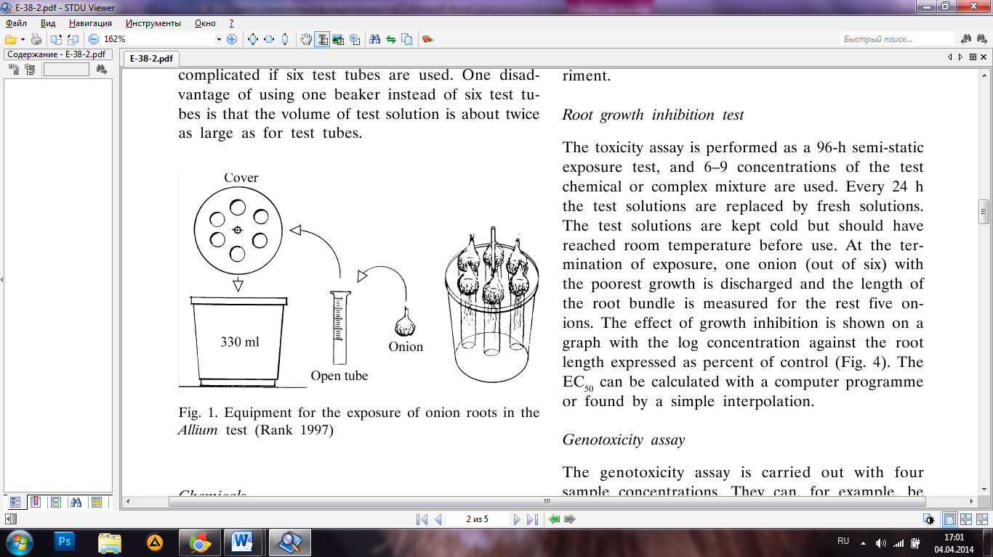

*Chemicals*

Tap water of good quality is used for negative control and for dilution of chemicals. Good quality means, for example, that the water is not containing any chlorine compounds and that the water pipes are not made of copper. If the quality of the tap water is poor, it is recommended to use synthetic fresh water made of Millipore water containing

MgSO4 60 mg/l, NaHCO3 96 mg/l, KCl 4 mg/l and CaSO4 60 mg/l (CaSO4 which should be dissolved by heating and stirring before it is mixed with the other salts). If the test chemicals are not water- soluble, DMSO, acetone or ethanol can be used as a solvent. Methyl methanesulfonate (MMS) can be used as positive control. Fixation and maceration is carried out using a solution of 9 parts of 45% acetic acid and 1 part of 1 M HCl. The chromosomes are stained with 2% orcein in 45% acetic acid.

*Microscope and photo equipment*

A light microscope (e. g., Dialux from Leitz) is used with an oil immersion objective and 500D magnifi­cation. For discussion of aberrations, it is useful to install a video camera on the microscope and trans­fer the pictures to a computer.

**METHODS**

Prior to the Allium test the pH of an environmental sample (e. g., wastewater) should be adjusted to about 7 with 1 M HCl or NaOH. The test is carried out at room temperature and the onions should be kept away from direct sunlight during the experiment.

*Root growth inhibition test*

The toxicity assay is performed as a 96-h semi-static exposure test, and 6-9 concentrations of the test chemical or complex mixture are used. Every 24 h the test solutions are replaced by fresh solutions. The test solutions are kept cold but should have reached room temperature before use. At the ter­mination of exposure, one onion (out of six) with the poorest growth is discharged and the length of the root bundle is measured for the rest five on­ions. The effect of growth inhibition is shown on a graph with the log concentration against the root length expressed as percent of control (Fig. 4). The EC50 can be calculated with a computer programme or found by a simple interpolation.

*Genotoxicity assay*

The genotoxicity assay is carried out with four sample concentrations. They can, for example, be composed of the EC50 as the highest concentration followed by 50%, 25% and 10% of the EC50. Tap water or synthetic fresh water can be used as a negative control, and if DMSO or other solvents are used, a solvent control should be included in the assay. MMS, 10 mg/l, is used as positive con­trol, but maleic hydrazide, 5 mg/l, can also be used. Six onions are exposed to each concentration. For the first 24 h, the onions are grown in tap water or synthetic fresh water, whereafter they are exposed to the test chemicals for 48 h, which is close to two cell cycles. As for the toxicity test, the test solution is changed after 24 h. The onion with the poorest growth is excluded for every concentration, and the remaining five onions are prepared for microscopy.

For every onion one slide is made using the fol­lowing procedure: 5 root tips at a length of 10 mm are cut off and placed in a test tube with 2 ml acetic acid - hydrochloric acid solution and heated for 5 min at 50 °C. Thus, the root cells will become fixed and macerated. Thereafter, the roots are placed on a slide and the terminal root tips (1-2 mm) are cut off and used for further preparation. The rest of the material is removed from the slide and the excess of liquid is sucked up by a piece of blotting paper. Two drops of fresh filtrated 2% orcein solu­tion are added and mixed with the root tips by stirring and knocking with a blunt stick of stainless steel (or something alike). In the final phase, a co­ver slip is placed on the root cells and allowed to absorb stain for 5-10 min. Afterwards, the cells are squashed by placing to layers of blotting paper on the cover glass and pressing slightly down with the thumb. The cover slip is fixed carefully to the slide with nail varnish. The slides can be kept fresh for 2 months in a freezer.

*Microscopic examination*

All slides are coded and examined blind. The micros­copic analysis includes the mitotic index and sco­ring of chromosome aberrations in anaphase and telophase cells. The mitotic index, MI is found by counting all stages of mitotic cells out of 1000 cells. It is recommended only to score chromosome aber­rations if MI is above 10, otherwise there will be too few anaphase and telophase cells for the analy­sis. The slides are examined from right to left, up and down, and the first 100 anaphase and telopha­se cells are scored for aberrations.

Two classical categories of aberrations, fragments and bridges, are scored. These are the most fre­quent aberrations and indicate that the test chemi­cal or complex mixture is clastogenic. Very often fragments are seen together with bridges and these cells can be scored as a specific category. Figure 2 shows how chromatid breakage and rejoining can result in these aberrations. Categories as vagrant and laggards indicating interaction with the spindle are also scored. Other less frequent aberrations such as multipolarity, c-mitotic anaphases, polyploidy and pulverised chromosomes, are also registered. Diffe­rent kinds of aberrations are shown in Fig. 3.

The control level from exposure to tap water or synthe tic freshwater is about 1% of aberrant cells, and for the positive control with MMS, 10 mg/l, or maleic hydrazide, 5 mg/l, it is about 25% of aberrant cells. If the toxicity is not too high, it is possible to score 100 anaphase and telophase cells per slide. With five onions per beaker it gives 500 cells per concen­tration. However, if the mitotic index is very low, it can be impossible to find 100 cells per onion.

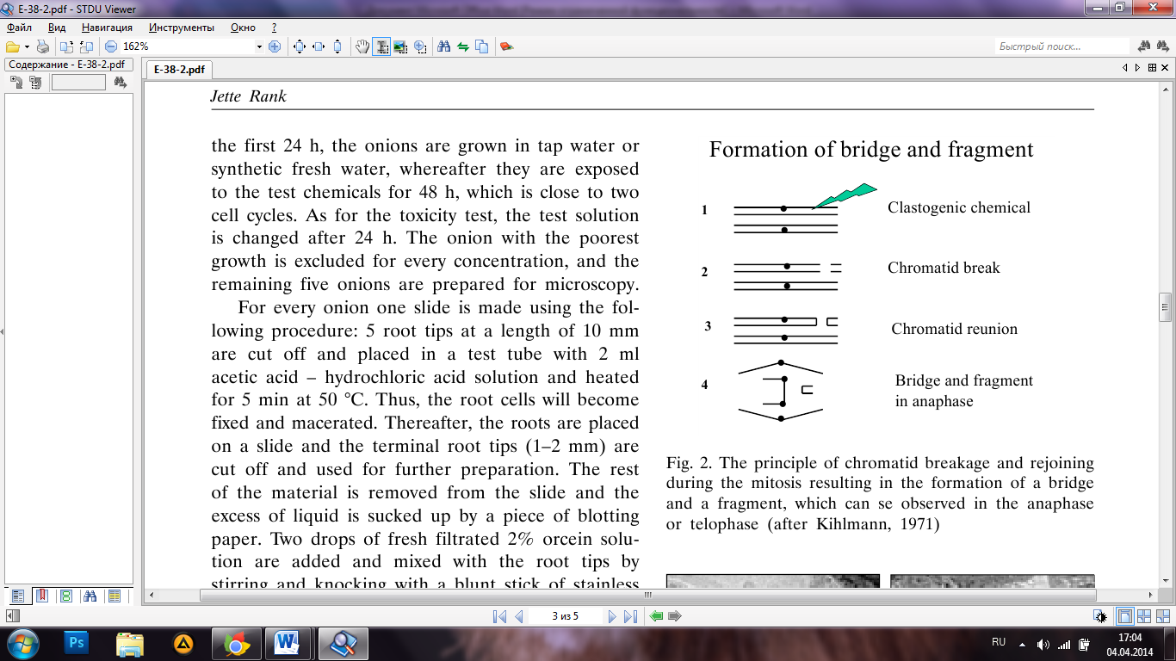

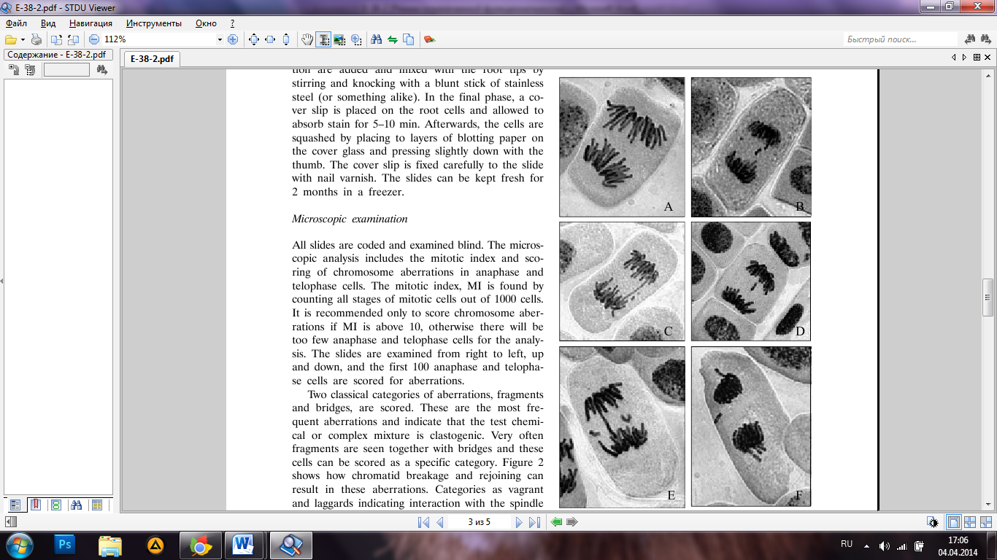

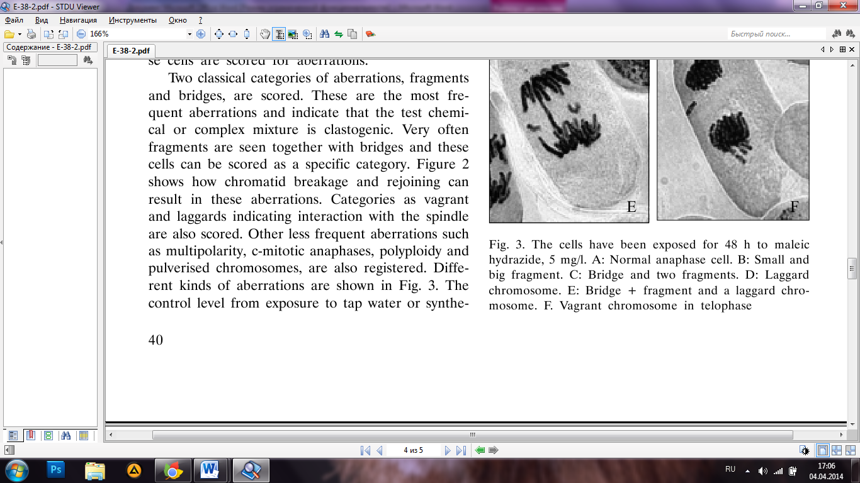

*Statistics*

As the distribution of aberrant cells is binomial, we used the χ2-test for statistical calculations. The calculations were carried out on the assumption that the five onions made one sample, and each concentration was tested against the control sample.

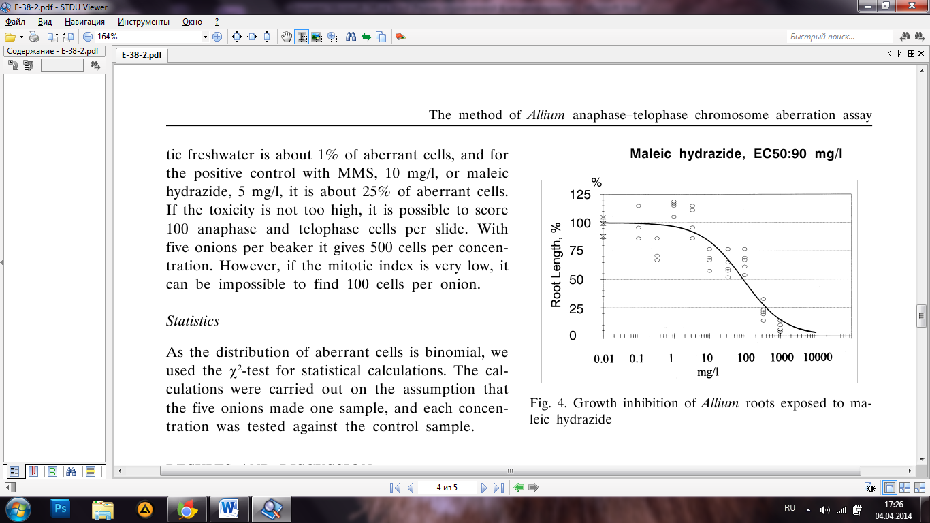

**RESULTS AND DISCUSSION**

The results from a 96-h root growth inhibition test of maleic hydrazide are shown in Fig. 4. The sig­moid graph is a typical dose-response curve for this kind of toxic effects. However, if the chemical or environmental sample has a low acute toxicity, it can be difficult to obtain a usable graph for deter­mination of EC50. From earlier studies (Nielsen, 1994; Rank et al., 1994; Rank et al., 1998), EC50 values from testing chemicals, wastewater and waste­water sludge are shown (Table 1).



Table 2 shows the corresponding results from ne­gative and positive controls. When tap water was used as negative control (Rank et al., 1997), 0.2% and 1.4% of aberrant cells were found, and for synthetic freshwater (Rank et al., 2002) the values were 0.4% and 1.6%. The present results for MMS, 10 mg/l, varied from 18.4% to 28.6%, but in other studies we have seen levels lower than 10% of aber­rant cells. The explanation for these variations is that MMS degrades very fast, even if it is kept cold, and therefore it is recommended not to use a batch for more than half a year after it is opened.

In Table 2 one can see that MMS, 10 mg/l, decreased the mitotic index (9–21%) compared tothe controls. Further, a big variation (42–65) can be seen for the MI of the controls. Therefore, it could be questioned if the MI should be used as a quantitative measure of toxicity, and in the Allium anaphase-telophase chromosome aberration assay the MI is only used for evaluation purposes to see if there will be mitotic cells enough for the analysis of chromosome aberrations. As pointed out earlier, it has been found that with an index below 10 there will normally be too few anaphase and telophase cells to score at the slide.

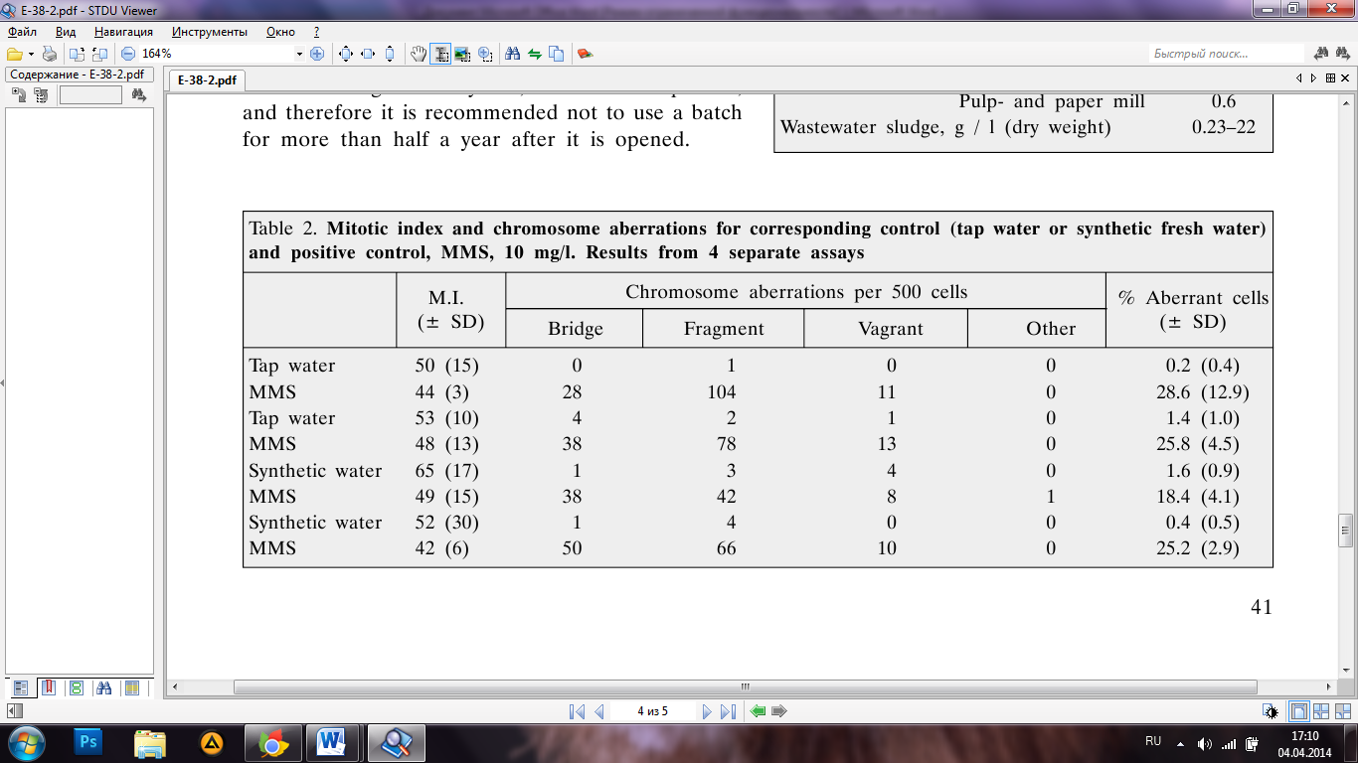

The Allium anaphase-telophase chromosome aberration assay was developed as a modification of the Allium test described by Fiskesjo (1985) to make a simpler and faster assay for detection of the ge- notoxicity of chemicals and environmental samples. Fortunately, the test system has been found useful for many different studies. Odeigah et al. (1997) used the Allium test to show the genotoxicity of wastewater from an oil field, and Monarca et al. (2000) investigated urban wastewater disinfected by different chemicals and showed a positive response in the Allium test when peracetic acid was used as a disinfectant. The Allium test also showed good results when aqueous extracts from lead-contami­nated soils before and after remediation were exami­ned for genotoxic effects (Chang et al., 1997). Fur­ther, in a soil study using the Allium test, Koval­chuk et al. (1998) found a strong, significant corre­lation of chromosome aberrations with 137Cs activity in soils contaminated by the Chernobyl accident.

In conclusion, the Allium cepa anaphase- telophase chromosome aberration assay is useful for many types of environmental samples and can be recommended as a tool for monitoring the genoto- xic effects and thereby contributing to environmen­tal risk assessment m eans, which are becoming ever more important.

References

1. Chang L. W., Meier J. R., Smith M. K. Application of plant and earthworm bioassays to evaluate reme­diation of a lead-contaminated soil. Archives of Envi­ronmental Contamination and Toxicology. 1997. Vol. 32. P. 166-171.
2. Claxton L. D, Houk V. S., Hughes T. J. Genotoxicity of industrial wastes and effluents. Mutation Research. 1998. Vol. 410. P. 237-243.
3. Fiskesjo G. The Allium test as a standard in the en­vironmental monitoring. Hereditas. 1985. Vol. 102. P. 99-112.
4. Fiskesjo G. The Allium test - an alternative in envi­ronmental studies: The relative toxicity of metal ions. Mutation Research. 1988. Vol. 197. P. 243-269.
5. Grant W. F., Lee H. G., Logan D. M., Salomone M. F. The use of Tradescantia and Vicia faba bioassays for the in situ detection of mutagens in an aquatic environ­ment. Mutation Research. 1992. Vol. 270. P. 53-64.
6. Kihlman B. A. Root tips for studying the effects of chemicals on chromosomes. In: A. Hollaender (ed.). Chemical Mutagens. Plenum Press, New York, 1971. P. 449-514.
7. Kovalchuk O., Kovalchuk I., Arkhipov A., Telyuk P., Hohn B., Kovalchuk L. The Allium cepa chromosome aberration test reliably measures genotoxicity of soils of inhabited areas in the Ukraine contaminated by the Chernobyl accident. Mutation Research. 1998. Vol. 415. P. 47-57.
8. Monarca S., Feretti D., Collivignarelli C., Guzzella L., Zerbini I., Bertanza G., Pedrazzani R. The influ­ence of different disinfectants on mutagenicity and toxicity of urban wastewater. Water Research. 2000. Vol. 34. No. 17. P. 4261-4269.
9. Nielsen M. H., Rank J. Screening of toxicity and ge- notoxicity in wastewater using the Allium test. Here- ditas. 1994. Vol. 121. P. 249-254.
10. Odeigah P. G. C., Nurudeen O., Aund O. O. Geno- toxicity of oil field wastewater in Nigeria. Hereditas. 1997. Vol. 126. P. 161-167.
11. Rank J., Nielsen M. H. A modified Allium test as a tool in the screening of genotoxicity of complex mix­tures. Hereditas. 1993. Vol. 118. P. 49-53.
12. Rank J., Nielsen M. H. Evaluation of the Allium anap- hase-telophase test in relation to genotoxicity scree­ning of industrial wastewater. Mutation Research. 1994. Vol. 312. P. 17-24.
13. Rank J., Nielsen M. H. Allium cepa anaphase-telo- phase root tip chromosome aberration assay on N-methyl-N-nitrosourea, maleic hydrazide, sodium azi- de, and ethyl methansulfonate. Mutation Research.
14. Vol. 390. P. 121-127.
15. Rank J., Nielsen M. H. Genotoxicity testing of was­tewater sludge using the Allium cepa anaphase-telop- hase chromosome aberration assay. Mutation Research.
16. Vol. 418. P. 113-119.
17. Rank J., Lopez L. C., Nielsen M. H., Moretton J. A two-laboratory study of the Allium cepa anaphase-te- lophase chromosome assay comparing genotoxicity of maleic hydrazide, acridine and DEHP. Hereditas. 2002. Vol. 136. P. 13-18.

Jette Rank

ALLIUM ANAFAZINIy-TELOFAZINIy CHROMOSO­ME ABERACIjy TYRIMO METODAS

Santrauka

Svoguno Allium anafaziniq-telofaziniq chromosomq abe- racijq tyrimo metodas buvo sukurtas greitam cheminiq me- dziagq ir aplinkos pavyzdziq genotoksikologiniam jvertini- mui. Pries genotoksiskumo tyrimq atliekamas 96 val. truk- mes sakneliq augimo inhibicijos testas. Chromosomq abe- racijos nustatomos sakneles paveikus tiriamj medziaga 48 val. Klastogeniskumo rodikliai yra atsirandantys chro- mosomq tiltai ir fragmentai, o atsiliekancios ir pasimetu- sios chromosomos rodo aneugeninj poveikj. Metodas yra greitas bei patikimas ir gali buti taikomas nutekamiesiems vandenims, upes vandenims, uzterstoms dirvoms ir sude- tingiems misiniams tirti.

**Raklazodziai:** Allium cepa, genotoksiskumas, chromo- somq aberacijos, anafaze, telofaze

Jette Rank

ALLIUM ANAFAZINIy-TELOFAZINIy CHROMOSO­ME ABERACIjy TYRIMO METODAS

Santrauka

Svoguno Allium anafaziniq-telofaziniq chromosomq abe- racijq tyrimo metodas buvo sukurtas greitam cheminiq me- dziagq ir aplinkos pavyzdziq genotoksikologiniam jvertini- mui. Pries genotoksiskumo tyrimq atliekamas 96 val. truk- mes sakneliq augimo inhibicijos testas. Chromosomq abe- racijos nustatomos sakneles paveikus tiriamj medziaga 48 val. Klastogeniskumo rodikliai yra atsirandantys chro- mosomq tiltai ir fragmentai, o atsiliekancios ir pasimetu- sios chromosomos rodo aneugeninj poveikj. Metodas yra greitas bei patikimas ir gali buti taikomas nutekamiesiems vandenims, upes vandenims, uzterstoms dirvoms ir sude- tingiems misiniams tirti.

**Raklazodziai:** Allium cepa, genotoksiskumas, chromo- somq aberacijos, anafaze, telofaze

1. **Read the glossary given below to study how to make the glossary of your own. Find sentences in the article where the terms are used and translate them**

*Jette Rank, Meete H. Nielsen*

**THE METHOD OF ALLIUM ANAPHASE-TELOPHASE CHROMOSOME**

**ABERRATION ASSAY**

*Department of Environment, Technology and Social Studies, Roskilde University, Denmark*

**Glossary**

1. **Acetic acid** - weak-acid monobasic carboxylic substance which is used for fixation, maceration and staining of chromosomes.

*Уксусная кислота* - *слабая одноосновная карбоновая кислота, которая используется для фиксации, мацерации и окрашивания хромосом.*

1. **Allium сера**- the most widely cultivated specie of the genus Allium.

*Репчатый лук* - *самый широко культивируемый вид из рода Лук.*

1. **Allium test** - plant test system for the assessment of chemical and physical mutagens with *Allium сера.*

*Allium тест - растительная тест система для анализа химических и физических мутагенов с помощью репчатого лука.*

1. **Anaphase** - the stage of mitosis, when chromosomes move to opposite poles of the cell.

*Анафаза* - *стадия митоза, когда хромосомы движутся к противоположным полюсам клетки.*

1. **Blotting paper** - a highly adsorbing type of paper, which is called sometimes a bibulous paper.

*Бумага для блоттинга - высоко адсорбирующий тип бумаги, которую иногданазываютгигроскопическойбумагой.*

1. **Cell cycle** - the series of events occurring in a cell between one division and the next.

*Клеточный цикл - ряд событий, происходящих в клетке от одного деления до следующего.*

1. **Chromosome** - one of the DNA-protein structures, that contains part of the nuclear genome of a eukaryote.

*Хромосома - одна из ДНК-белковых структур, которая содержит часть ядерного генома эукариот.*

1. **Chromosome aberration** - abnormalities of the structure or number of chromosomes, which are often responsible for genetic disorders.

*Хромосомная аберрация* - *аномалии структуры или числа хромосом, которые часто ответственны за генетические заболевания.*

1. **Chromosome bridge**- dicentric chromosome, which consist of two contralateral chromatid.

*Хромосомный мост* - *дицентрическая хромосома, которая состоит из двух перекрещенных хроматид.*

1. **Chromosome fragments** - a double or single fragments or parts of chromosome.

*Хромосомные фрагменты* - *парные или одиночны фрагменты или части хромосомы.*

1. **Chromatid** - the arm of a chromosome.

*Хроматида*-*плечохромосомы.*

1. **Clastogen**- factor (usually it is chemical substance) is caused of formation of chromosome aberration.

*Кластоген*-*фактор (обычно это химическое вещество), являющийся причиной образования хромосомных аберраций.*

1. **DMSO (dimethyl sulfoxide)** - an organic compound which can dissolves an organic and inorganic chemical substance and is the best solvent.

*ДМСО (диметилсулъфоксид) - органическое соединение, которое может растворять органические и неорганические вещества и является сверхрастворителем.*

1. **Dose-response relationship** - the relation between the dose of a drug or other chemical and the degree of response it produces, as measured by the percentage of the exposed population showing a defined effect.

*Зависимость доза-реакция - соотношение между дозой лекарства или других химических веществ и степенью ответа, которую она вызывает, если судить по доле популяции, в которой наблюдается определенный эффект.*

1. **Environmental monitoring** - the observation, analysis and assessment of the environment and its changes under the influence of human activities, as well as prediction of the changes.

*Мониторинг окружающей среды - наблюдение, анализ и оценка состояния окружающей среды, её изменений под влиянием хозяйственной деятельности человека, а также прогнозирование этих изменений.*

1. ЕС50 **(half maximal effective concentration)** - the concentration of a drug, antibody or toxicant which induces a response halfway between the baseline and maximum after some specified exposure time.

*ЭК50 (половина максимальной эффективной концентрации) - концентрация препарата, антитела или токсического вещества, которая индуцирует половинный ответ между базовым и максимальным после некоторого заданного времени экспозиции.*

1. **Fixation** - the treatment of biological material in order to preserve their structure in the invariable state before microscopy.

*Фиксация — обработка биологического материала с целью сохранить их структуры в неизменном состоянии перед микроскопированием.*

1. **Genotoxic substances** - chemical compounds, which influence the genome of cell and have such negative effects as mutagenic, carcinogenic or teratogenic.

*Генотоксические соединения - химические соединения, которые оказывают влияние на геном клетки и обладают такими негативными последствиями как мутагенными, канцерогенными или тератогенными.*

1. **Genotoxity**- the property of chemical, physical and biological factors have a damaging effect on genetic structure of the organism.

*Генотоксичность*-*свойство химических, физических и биологических факторов оказывать повреждающее действие на генетические структуры организма.*

1. **Heavy metals** - the group of chemical elements with properties of metals or semimetals and considerable atomic weight or density.

*Тяжелые металлы ~ группа химических элементов со свойствами металлов или полуметаллов и значительным атомным весом либо плотностью.*

1. **Hydrochloric acid** - the strong monobasic inorganic acid, which is used for maceration.

*Соляная кислота* - *сильная одноосновная неорганическая кислота, использующаяся для мацерации.*

1. **In situ** - the phenomenon is seen in the place where it occurs, without movement of it in a special environment.

*На месте - явление рассматривается на месте, где оно происходит, без перемещения в специальную среду.*

1. **Laggard chromosome** - the chromosome, whose speed of movement during the cell division is less than the rest chromosomes.

*Отстающая хромосома - хромосома, чья скорость движения во время деления клетки меньше, чем у остальных.*

1. **Maceration** - the separation of plant and animal cells in the tissues by means of dissolution of intercellular substance.

*Мацерация ~ разъединение растительных или животных клеток в тканях путем растворения межклеточного вещества.*

1. **Maleic hydrazide**- the plant growth regulator, which is toxic in high concentrations.

*Малеиновый гидразид - регулятор роста растений, являющийся токсичным в больших концентрациях.*

1. **MMS (methyl methanesulfonate)** - an organic compound that is a direct carcinogen, which damages the structure of DNA.

*MMC(метилметансулъфонат)* - *органическое соединение, являющееся канцерогеном прямого действия, который повреждает структуру ДНК.*

1. **Microscopical slides** - thin plates of a substance or tissue intended for study under the microscope.

*Микроскопические препараты - тонкие пластинки вещества или ткани, предназначенные для изучения под микроскопом.*

1. **Micronuclei**- pathological structure, which has a round shape, small size and locates near the main core.

*Микроядро - патологическая структура округлой формы, небольших размеров и располагающаяся вблизи основного ядра.*

1. **Mitosis**- indirectcelldivision.

*Митоз – непрямоеделениеклетки.*

1. **Mitotic cells** - intensively dividing cells.

*Митотические клетки* - *интенсивно делящиеся клетки.*

1. **Mitotic index (MI)** - the percentage of divided cells of the total number of analyzed cells.

*Митотический индекс (МИ) - процент делящихся клеток от общего числа проанализированных клеток.*

1. **Multypolarity**- the presence of more than one nucleus in the cell.

*Многополярность - наличие в клетке больше чем одного ядра.*

1. **Mutagenicity** - the ability of physical, chemical or biological agent is cause of mutation.

*Мутагенность ~ способность физического, химического или биологического агента вызывать мутацию.*

1. **Negative control** - the substance, which is not mutagenic or toxic and has the smallest quantity of cell damages.

***Негативный контроль*** *— вещество, не являющееся мутагенным или токсичным и имеющее самое небольшое количество клеточных повреждений.*

1. **Oil immersion** - the introduction of oil liquid between microscope objective and concerned item for the increasing of brightness and the expansion of limits of image magnification.

*Масляная иммерсия* - *введение масляной жидкости между объективом микроскопа и рассматриваемым предметом для усиления яркости и расширения пределов увеличения изображения.*

1. **Orcein**- a natural colorant which is produced from lichens and used for staining of chromosomes.

*Орсеин*— *природный краситель, который производится из лишайников и используется для окрашивания хромосом.*

1. **Polyploidy** - an increasing of number of chromosome sets in cells of organism which is multiple of haploid (single) chromosome number.

*Полиплоидия* - *увеличение числа наборов хромосом в клетках организма, кратное гаплоидному (одинарному) числу хромосом.*

1. **Positive control** - mutagenic substance, which cause an increasing of quantity of chromosome aberrations and reducing the value of mitotic index.

*Позитивный контроль — мутагенное вещество, которое вызывает увеличение количества хромосомных аберраций и снижает величину митотического индекса.*

1. **Pulverized chromosomes** - all or some chromosomes are destroyed on separate fragments and distribute in the nuclear field.

*Разбросанные хромосомы - все или некоторые хромосомы разрушены на отдельные фрагменты и распределены в поле ядра.*

1. **Rack** - portable support for tubes or other laboratory glassware to keep them in an upright position. *Штатив - переносная опора для пробирок или другой лабораторной посуды для поддержания их в вертикальном положении.*
2. **Salmonella test or Ames test** - mammalian test system to assess the mutagenic potential of chemical compounds with Salmonella.

*Сальмонелла тест или Тест Эймса - животная тест система для анализа мутагенного потенциала химических соединений с помощью сальмонеллы.*

1. **Spindle** - the structure which consists of microtubules and appears during the nucleus division in the cells.

*Веретено деления - структура, состоящая из микротрубочек и возникающая во время деления ядра в клетках.*

1. **Synthetic fresh water** - the water is not containing any chlorine compounds or containing ions of metals, anions of acids and other organic and inorganic chemical substance in low numbers.

*Синтетически чистая вода - вода, не содержащая соединений хлора или содержащая ионы металлов, анионы кислот и других органических и неорганических химических веществ в небольших количествах.*

1. **Telophase**- a stage of mitosis, when two distinct daughter cells are formed.

*Телофаза - стадия митоза, когда формируются две отдельные дочерние клетки.*

1. **Toxity**- the ability of substance to cause dysfunction of physiological processes of the body that is cause of intoxication, diseases or even death.

*Токсичность* - *способность вещества вызывать дисфункцию физиологических процессов организма, что является причиной интоксикации, заболевания или даже гибели.*

1. **Tube** - specialized cylindrical vessel which have a semicircular, conic or flat bottom or can be bottomless and is used in laboratory purposes.

*Пробирка - специализированный сосуд цилиндрической формы, имеющий полукруглое, коническое или плоское дно или может быть бездонным, использующийся в лабораторных целях.*

1. **Vagrant chromosome** - the chromosome, which locates in the cytoplasm outside the metaphase plate and doesn't involve in division of cell.

*Блуждающая хромосома* - *хромосома, располагающаяся в цитоплазме вне метафазной пластинки и не участвующая в делении клетки.*

1. **Xtest**- the most frequently used criterion for the check of hypothesis about the low of distribution.

*Xтест - наиболее часто используемый критерий для проверки гипотезы о законе распределения.*

**3. Take the chosen article and make glossary of 30-40 units.**